**Golden Chalet**

**7225 Ryan Gulch Rd. Silver Queen West, Silverthorne, CO 80498**

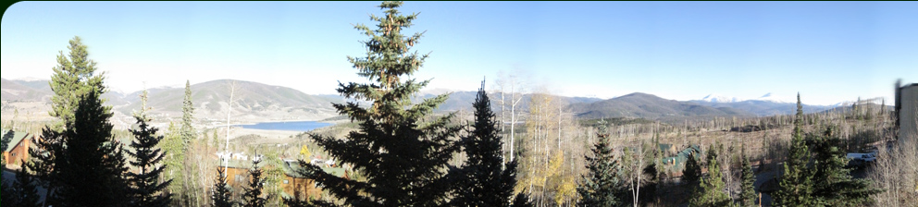

The address is above, but online mapping websites may not put you right in front. The proper location is here

<http://maps.google.com/maps?q=39.618844,-106.091784&num=1&t=h&sll=39.619144,-106.091259&sspn=0.007,0.010139&ie=UTF8&ll=39.61877,-106.091945&spn=0.00175,0.002535&z=19>

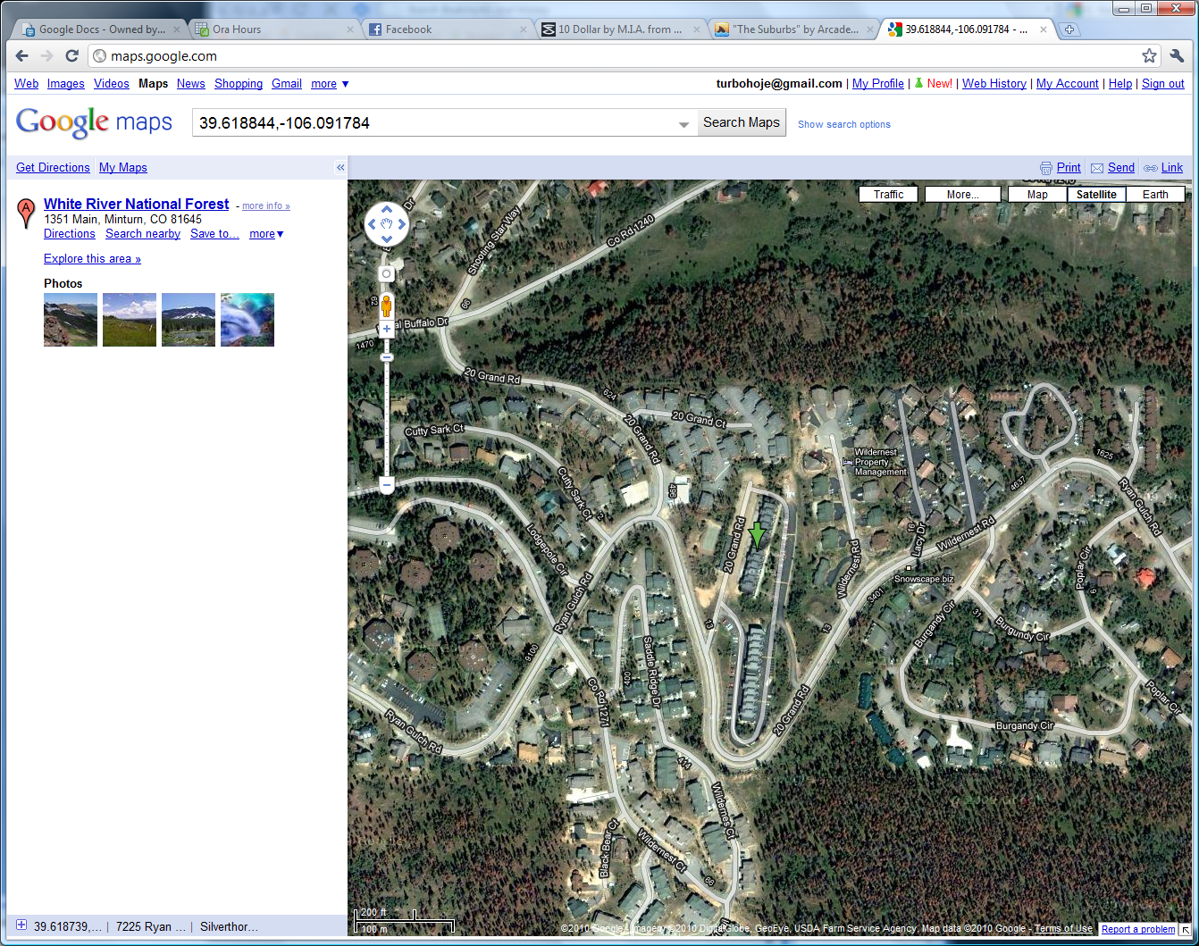

As you pull into Silver Queen West, we are building C. From the lot the building looks like this.

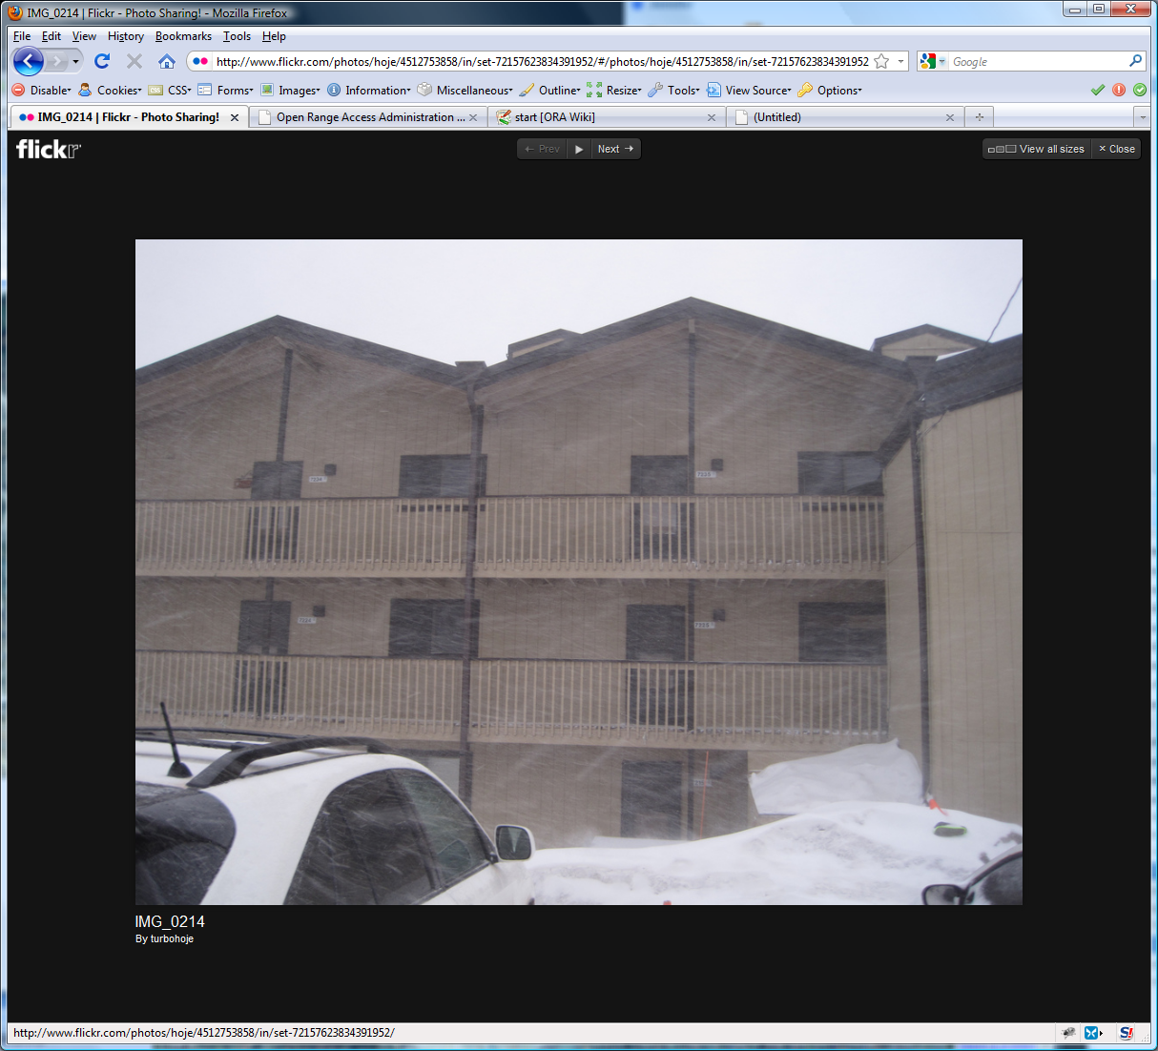

This is it!

Park anywhere out front, it is not assigned. If you have a diesel or have a block heater; there is an outdoor plug on the south end of the garages.

# Door Lock

**Only use the deadbolt. When you leave, please don’t lock the door handle as we don’t carry a key for it.**

**Unlock**:

Mash in your code, spin it to the right. If it is dark, the Schlage button on the top will backlight them for easier mashing.

**Lock**:

Push the “Schlage” button on the top and spin the handle to the left. The handle will disengage electronically after a few seconds.

# Places to Eat

By no means is this all, but this is some of our regulars.

**Sunshine Café**

([http://sunshine-cafe.com](http://sunshine-cafe.com/))

This is our favorite place for breakfast. They have great food and coffee, however it comes at a price. There is always a wait and its awesomeness is no secret. Sunshine is often the warm bosom you need to lay your pounding head in after a rowdy night of drinking. Get a banana nut muffin, it will make love to your mouth.

**Blue Moon Deli**

(<http://www.bluemoonbakery.net/>)

There is not much room to eat here, but they make good sandwiches. Breakfast burritos are good, but large to eat on your own before skiing. They are like the mountain equivalent of an Einstein’s or something. Also there is a liquor store next door you can pick up a bottle of champagne, and get some OJ here to make mimosas pre-skiing or while you wait for a table at sunshine.

**Red Mountain Grill**

(<http://www.redmountaingrill.com/>)

Great Food, good pizzas.

**Dam Brewery**

(<http://www.dambrewery.com/>)

Bar food, but more where the après-ski drinking scene is at

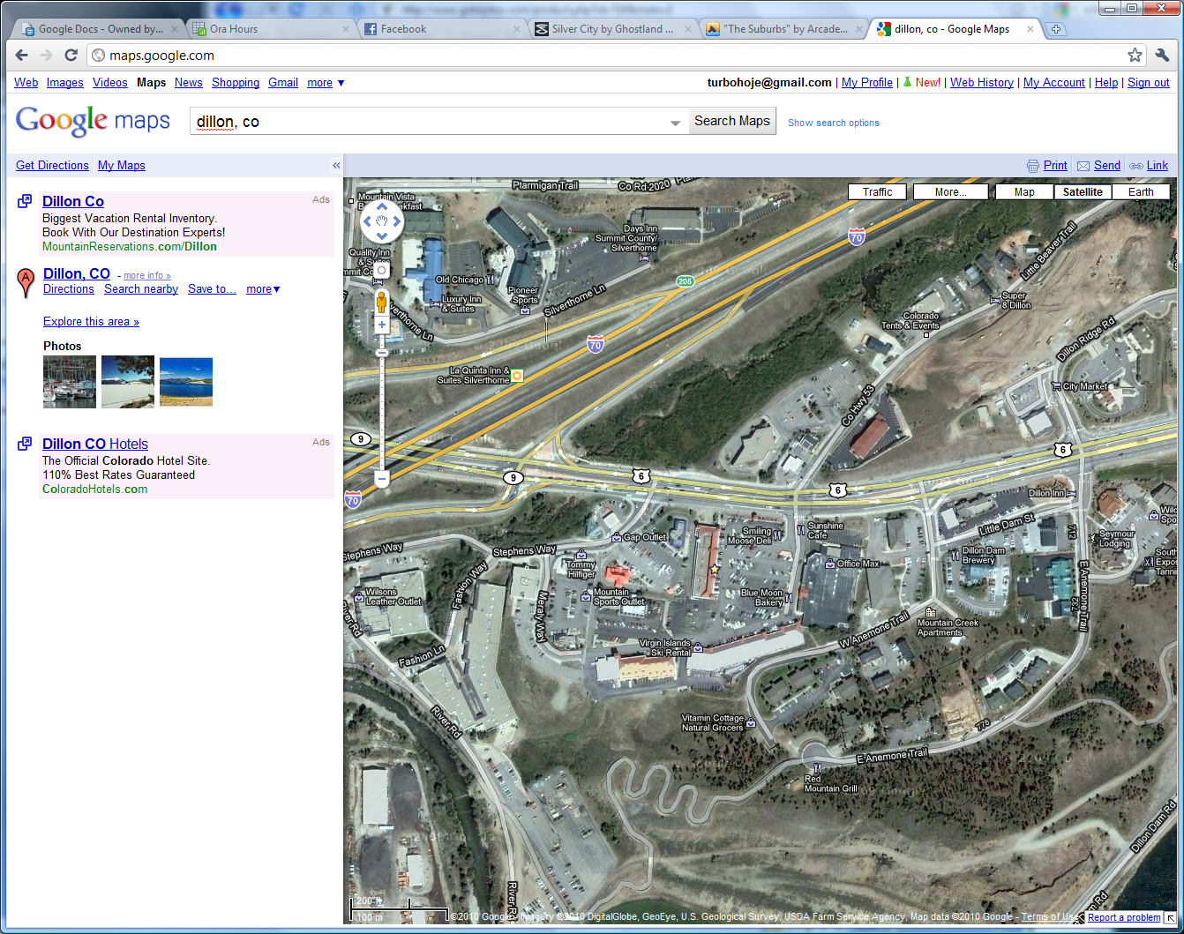

Sunshine Blue Moon Damn Brewry Red Mtn

# Heat

We find there is often too much of it. The place is heated by a central boiler and circulates near solar temperature water to each of the rooms. The thermostat on the wall in the living room controls when the solenoid opens. To prevent freeze ups and corrosion the solenoid never fully closes to always allow some degree of fluid circulation, and this is more than enough to heat the condo.

You will probably have to crack some windows to get the temp down to a comfortable place, just be sure to close them up when you leave.

There are fans in both bedrooms. The guest bed has a fan in the nightstand and the master has one that works great on the floor when the window is cracked.

# Trash

There is a dumpster on the north side of the garages that are across from the front door. It has a bear-lock on it that consists of a cable pulled over a bolt. If you find it locked, please lock it again. Feeding the bears after midnight makes bear-gremlins and we don’t want that again.

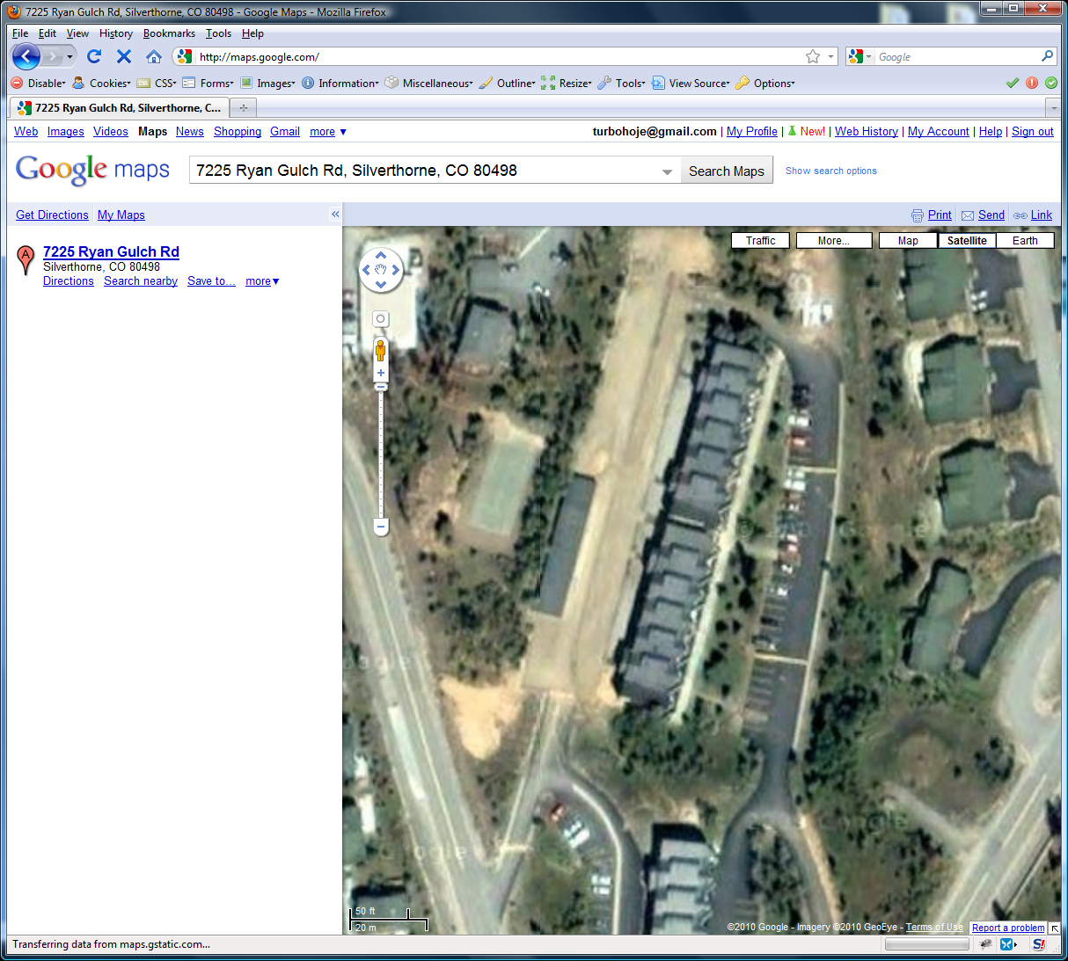

Condo

Dumpster

# DVD/PS3

There is a PS3 mounted on the wall behind the TV. Usually I leave it physically shut off when I leave (on the back of the unit) because there is some dirty power up there and they don’t seem to do so well with that.

If you are unfamiliar with Playstations, you can turn them on with either remote by pressing the big circular “PS” button. The TV must be on HDMI input, and the rest is fairly straight forward. If a remote doesn’t work, press its PS button as it may need to be

Two games we enjoy are BUZZ trivia and Gran Tourismo 5. Buzz can be played with the traditional Playstation controller and the Playstation DVD style remote.

The Playstation has a USB cable hanging on the TV mount. This can be used to view most video types and pictures directly from the device. The controllers and other devices can be charged using this while the PS3 is on. There is also a USB charger in the hutch by the kitchen if you need.

# Summit Stage Bus

The summit stage bus stop is right across the street from silver queen west. It comes every 30 minutes. More information can be found here: <http://www.summitstage.com/>

We have only ridden it once. It took us 70 minutes from the time we got on the bus to make it to keystone with the bus switch and all the stops. It’s really easy to ride and or figure out, but isn’t the fastest.

# Internet

Connect to any of the arrrg networks that work best. The WEP key is **skier**.

# Phone

We don’t have a land line, hope you’ve got a cell.

# Other

Please do not smoke indoors or bring animals.

# Contacts

**Jennifer**

303-570-3873

**Justin**

303-669-3787

**Tom Brennen**

(local property manager)

970-486-0222

Only call Tom if there are problems like fire or flood (or bear-gremlins)